**CORRELATION ANALYSIS**

1. Absolute correlation between prices: (Too High)

Correlation btw opening price and moving_avg_close: 0.9999159330039952

Correlation btw opening price and moving_avg_open: 0.9999159357825343

Correlation btw opening price and moving_avg_high: 0.9999038444680074

Correlation btw opening price and moving_avg_low: 0.999907416671106

Correlation btw opening price and ema_close: 0.9999344408972434

Correlation btw opening price and ema_open: 0.9999344427966503

Correlation btw opening price and ema_high: 0.999921495931576

Correlation btw opening price and ema_low: 0.9999272195016284

(Moving averages are shifted moving averages, not seeing the current tick size data)

1. Correlation between change% and volume: -0.034

Correlation btw abs change% and volume: **0.58**

Correlation between change% and lag volume: 0.019

Correlation between abs change% and lag volume: **0.32**

1. Correlation between the %change and %change_ema is: -0.036

Correlation between the abs %change and abs %change_ema is: **0.40**

**TIME SERIES FORECASTING AND ANALYSIS**

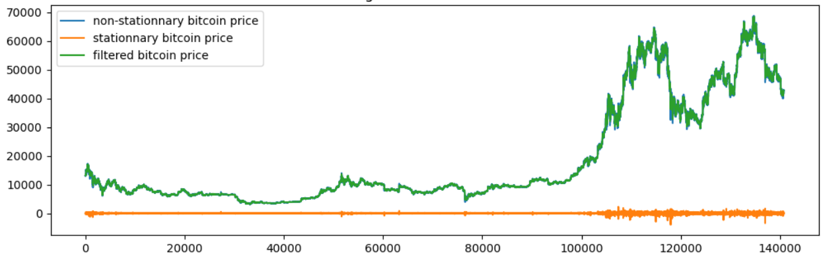

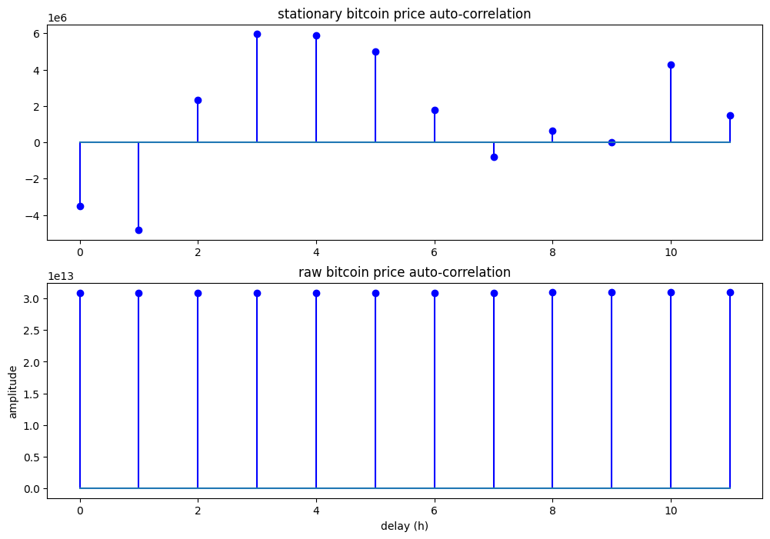

Positive Autocorrelation: If autocorrelation is positive at a certain lag, it indicates that high values tend to follow high values, and low values tend to follow low values with that time lag.

Negative Autocorrelation: Conversely, negative autocorrelation at a lag suggests an inverse relationship between values at the current time and values at the lagged time.

MAX PEAK OF AUTO-CORRELATION OF STATIONARY PART IS 3. (ie 5*3=15 mins)